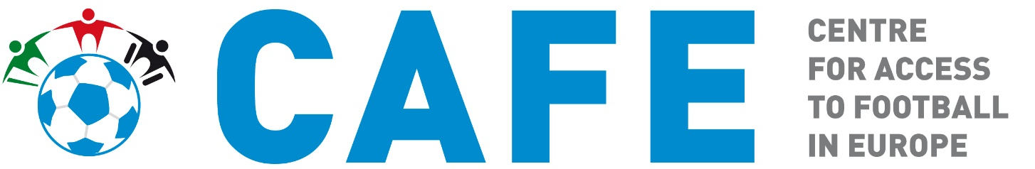

Proof of disability – UEFA Club Competitions
2020 / 2021 season
CAFE Guidance Note
September 2020

Alternative formats of this document are available upon request.
Please contact CAFE:
E: info@cafefootball.eu
T: +44 (0) 208 065 5108
Twitter: @cafefootball
Supported by

Contents

About the Guidance Note 3
2019/2020 UEFA Competition Finals 3
Why ask for Proof of Disability? 3
Accepted Proofs of Disability 3
Unacceptable Proof of Disability 4

About the Guidance Note
This aim of this guidance note is to provide additional support to disabled fans who are applying for accessibility tickets for UEFA Europa League and UEFA Champions League Final tickets via the UEFA ticketing portal.
The guide will help disabled fans who are wishing to apply for accessibility tickets for this season’s UEFA Competition Finals submit proof of disability which is acceptable, ensuring their application is valid.

2020 / 2021 UEFA Club Competitions
The UEFA Club competitions for the 2020 / 2021 season are:
UEFA Super Cup – Thursday 24 September 2020 at the Puskás Aréna, Budapest
UEFA Europa League Final – Wednesday 26 May 2021 at Gdańsk Stadium, Poalnd
UEFA Champions League Final – Saturday 29 May 2021 at the Atatürk Olympic Stadium, Istanbul

Why ask for Proof of Disability?
Accessibility tickets are available in two categories – wheelchair user tickets and easy access tickets. To help ensure accessibility tickets (and companion tickets where required) are correctly allocated, major event holders will often ask disabled spectators to provide valid proof of disability to support their application for tickets.
Requesting proof of disability also helps ensure that spectators with accessibility requirements are able to make use of accessible services and facilities available at venues. Likewise, evidencing disability can reduce numbers of fraudulent applications for accessibility tickets by non-disabled people.

Accepted Proofs of Disability
Accepted proof of disability varies from country to country, and often there are even regional variances on proofs within a country.
In order to apply for accessibility tickets for any of this season’s UEFA Club Competition Finals, disabled spectators are required to upload a valid proof of disability when submitting their application. The proof of disability should be one which is commonly and widely accepted in their country of residence.
Acceptable proofs of disability may include:
- National certificates of disability showing applicant’s name and validity dates (if applicable);

- Confirmation of receipt of disability related benefits dated within last two years showing applicants name, award details and validity dates (if applicable);

- Disabled persons’ ID cards – showing applicant’s name and validity dates (if applicable).
Please note: both sides of a disability card need to be submitted;

- Medical note / letter signed by your doctor or hospital consultant on official letterheaded paper and dated within the last two years. Medical letters must state applicants name;

- Disability passport showing applicants name and validity dates (if applicable);

- European Disability Card showing applicants name and validity dates (if applicable);
The above is not an exhaustive list of acceptable proofs. Each application received without a commonly accepted proof of disability will be reviewed on an individual case-by-case basis.

Unacceptable Proof of Disability
The list below details the most common unacceptable proofs of disability. If you submit any of the below, you will be contacted by UEFA and requested to provide an acceptable proof.
- Accessible Parking Permits, e.g. Blue Badge style passes;

- Selfies or photographs;

- Passports

- National identity cards

- Expired disability award letters or disability cards;

- Travel cards e.g. bus or train passes;

- Unsigned medical letters;

- Access Card (UK based applicants only);

- X-Rays;

- Prescriptions;

- Hospital admittance or discharge letters
If you do not provide sufficient proof of disability, you will be contacted by UEFA ticketing and requested to provide further additional proof to support your application.
If you have any questions regarding acceptable proof of disability, please contact CAFE by email on info@cafefootball.eu or call +44 (0) 208 065 5108.

T: +44 (0)208 065 5108 | E: info@cafefootball.eu |
www.cafefootball.eu |

Total Football
#TotalAccess

